

**Vrushali Patankar**

**She has completed M.S in education from the U.S and she has also completed her M.A. (English Literature) B.Ed from Pune University. Additionally she holds a diploma in French.**

**She has taught in different schools in Pune for about 10 years and also has 8 years of online tutoring experience for an American Company. She has also done content writing for a few websites and also works as a Subject Matter Expert for the Maharashtra State board.**

**She is presently working as a freelancer teacher trainer with Socrates Foundation for Enhanced Learning.**

**______________________________________________________________________________**

**5 E Lesson Plan**

**(A) General Information**

**Name of the School**: N/A

**Name of the Teacher**: Vrushali Patankar

**Date:**

**Subject:** History

**Grade:** 9th or 10th

**Topic:** World War

**Unit:** War

**Curriculum Standards**: CBSE

**(B) Lesson / Unit Planning:**

1. **Short Description of the Concept:** Teaching the causes of World War I with activities and reading material.
2. **Statement of Learning Objectives**: The students will be able to understand the causes that led to the war and critically evaluate it with the help of the tools and technology used while teaching.
3. **Differentiation strategies to meet diverse learner needs:** Each student will be able to take part actively in the discussion and activities as the activities are planned where participation of each student is required.
4. **Common Learners Misconceptions:** The students will learn the effective use of collaborative activities and tasks effectively while understanding the causes.
5. **Adaptations/ Accommodations’ for Exceptional Students:** Exceptional learners are welcome to go ahead and write more stories or write newspaper articles based on the tasks given in the classroom.
6. **Precautions/ Safety measures**: Respecting the mind of each student in order to avoid any conflicting or hurting issues during discussions.

**(C) Instructional Process:**

|  |  |  |  |
| --- | --- | --- | --- |
| **5 E’s** | **Activities** | **Guiding Questions** | **Materials** |
| **Engage** | **Watch the video and answer the questions** | 1. How will you explain the term ‘nationalism’ in reference to WWI? 2. Who was Archduke Ferdinand? 3. How was Germany made jealous? 4. What terms are introduced in the video? | Video  Internet connection |
| **Explore** | **Collaborative Activity** | 1. What do you think is the moral of the story? 2. How did Coachman Ali change? 3. What happened to the postmaster’s attitude towards the end? | Internet connection |
| **Explain** | **Reading article** | 1. Do you think they might have made some different choices before it was too late? 2. Describe how an assassination led to the war. 3. Identify the causes as you read the text. 4. Summarize the main ideas of the following article. | Internet connection |
| **Elaborate** | **Poster making** | 1. Find audio recordings of national anthems and the lyrics (and translations as needed) Create a handout with the national anthem lyrics in translation. | Internet connection and research |
| **Evaluate** | **Make a Rubric for evaluation** | Newspaper article and designing a flag activity | Rubric/poster |

**D) Reference/Resource:** CBSE Text Book

Unit: **Causes of World War I**

**Level: 9th grade**

**History** **Lesson Objectives:**

After the lesson, the students will be able to:

1. Recall the important terms related to the causes.
2. Recognize the main causes leading to the killing of Archduke Francis Ferdinand.
3. Describe the perspectives and interests of the countries involved in WWI.
4. Summarize the main ideas that they read in the article.
5. Illustrate through the poster their ideas about the events and alliances as they occurred.
6. Demonstrate their comprehension of historical documents by teaching each other through the interview and readings.
7. Analyze the changes and compare the situation in 1914 to present day.

**Time Frame:** 6 class periods

**Materials/ Resources:**

* Causes of WWI article: Sharon Fabian
* Poster making
* Newspaper headlines
* Role-play

**Vocabulary:**

Nationalism, Imperialism, Alliances, assassinations, militarism

**Period 1:**

**Knowledge:** **Activating Strategy/emotional Hook (Engage):**

At this level, children will watch the video on the causes of WWI.

<https://www.youtube.com/watch?v=24i4ncHuf6A>

They will be able to answer the following questions:

1. Which alliance was formed?
2. Can you recall the spark that set of WWI? Who was assassinated?
3. When did the assassination take place?
4. Can you list the 4 item names that came resulted in the causes for WWI?
5. What was the immediate cause of the war? What were the three underlying causes?
6. How did military alliances lead to WWI? What are the examples?
7. How will you explain the term ‘nationalism’ in reference to WWI?
8. Who was Archduke Ferdinand?
9. How was Germany made jealous?
10. What terms are introduced in the video?

Activities: Children will read one or more articles about WWI and the causes. Children will complete word searches and other puzzles.

As students go through the other learning activities, students will keep track of the causes that are covered in a notebook. In this exercise, students will meet in groups of 4 to discuss the causes. Students will be asked to create a one page write up that defines how the main causes of World War I: military alliances, imperialism, militarism, nationalism were set off by the assassination of Archduke Ferdinand.

Students will be asked to come up with a definition of each term, identify who Archduke Ferdinand was, and how his assassination was linked to each of these causes.

1. Who was Archduke Ferdinand?
2. Recall the main terms related to the causes of World war I
3. Define the terms clearly- military alliances, imperialism, militarism, nationalism.
4. Describe the alliances that took place.
5. Discuss possible causes for the arms race between Germany and Great Britain
6. In the discussion of military developments between Germany and Great Britain, have students sort the pictures into two categories based on the country who developed them.
7. Once this is done, have students discuss what other categories could be used to discuss the arms race (ideas include purpose, where they might be used).
8. Encourage students to think about how nationalism, imperialism, and the networks of alliances, and so forth contribute to driving the arms race.

**Home assignment:**

Reading Material 1--Causes of World War I

By Sharon Fabian

Many people didn't want a war to begin. Mothers and fathers all over Europe hoped for good lives for their sons who were just becoming adults. Young men hoped to begin their adult lives by going to work, getting married, and raising families. Instead, in 1914, many of them went to war. Some of the leaders in Europe didn't want the war to begin either. They tried to convince others not to go to war. Instead, one country after another declared war.

How did it happen? What caused World War I?

There were several causes of World War I. The most immediate cause was the assassination of Archduke Francis Ferdinand of Austria-Hungary. Austria-Hungary decided that Serbia was to blame for the assassination and declared war on Serbia. Before the assassination, there were other things going on in Europe that led up to the war.

One thing was an increase in the feeling of nationalism in many European countries. Nationalism is something like patriotism, so you may be surprised to hear that it was one cause of the war, but nationalism doesn't just mean supporting your own country. Nationalism means putting the interests of your own country above everything else and ignoring the rights of people in other countries.

Another cause of the war was military alliances. When two or more countries make an alliance, they agree to support each other if a war begins. Germany formed an alliance with Austria-Hungary, and Great Britain formed alliances with France and Russia.

The alliance made countries on both sides feel powerful. With their allies, they felt safe from attack. The alliances were a cause of the war because, once countries felt safe from attack, they also felt free to take actions that might anger other countries. Tensions built up among the countries of Europe.

As tensions built up, countries in Europe began to make more and more weapons. Each side wanted to be in a position of power, just in case.

With all of this going on, can you see why parts of Europe were referred to as a "powder keg"? The situation in Europe had made it a place that could explode at any moment, just like a barrel full of gunpowder.

The assassination of the archduke was the spark that set off the powder keg. Feelings of nationalism made countries decide to fight. Alliances brought in more countries. With stockpiles of weapons, a war could begin right away. World War I was the largest and most horrible war that had ever happened up to that time.

Answer the following questions:

1. Did it all have to happen?
2. Suppose the archduke had never been shot. Do you think the countries of Europe might have found other ways to solve their problems?
3. Do you think they might have made some different choices before it was too late?
4. Describe how an assassination led to the war.
5. Identify the causes as you read the text.
6. Summarize the main ideas of the following article.

**Period 2:**

**Explore/Explain: Comprehension**

Once children have learned significant facts about the causes that led to WWI, they will demonstrate an understanding. They will be able to do the following:

*Activities:*Children may do some or all of the following:

1. Explain the reasons that led to the killing of Archduke Ferdinand
2. Write the story of the causes of WWI in their own words
3. Sketch a diagram or make a poster that will explain the series of events that caused WWI

This will be a group task: 'persuade people to join the army' or 'keep everyone's spirits up'. The students will have to create effective propaganda posters to fulfill their task.

**Period 3:**

**Apply:**

At this level, children will apply the information they have learned to new situations. Children will be able to do the following:

*Activities:*Children may do some or all of the following:

1. Make a poster that discusses and connects the events and alliances as they occurred.
2. Construct an interview with a significant person involved in the Declaration of Independence
3. Write a list of questions to ask Archduke Francis Ferdinand and the Presidents of USA, France and Germany about their life and their contribution to the war.
4. Find audio recordings of national anthems and the lyrics (and translations as needed) Create a handout with the national anthem lyrics in translation.
5. Also, the students can find out some songs that helped to bolster each country’s morale in wartime.  For example:

Keep the Home Fires Burning'

'Goodbye-ee'

'Your King and Country Want You'

Home assignment:

* 1. Students will listen to three national anthems and reflect what emotions, ideas, and feelings are evoked by the music. They will record their responses in their books.
  2. Students will them listen to three more anthems (different ones) and look at the lyrics: what do the lyrics tell them out the country?
  3. Based on your knowledge, is this accurate? Why or why not? Students will then be asked to define nationalism and their answers are compared to a prepared definition.
  4. They will then be asked to reflect on how nationalism might be considered a cause of World War I as a group.
  5. Students will then listen to the final two anthems. Students will record how these anthems reflect the concept of nationalism.
  6. For homework, students will be asked to reflect on nationalism is manifested in the Indian national anthem.

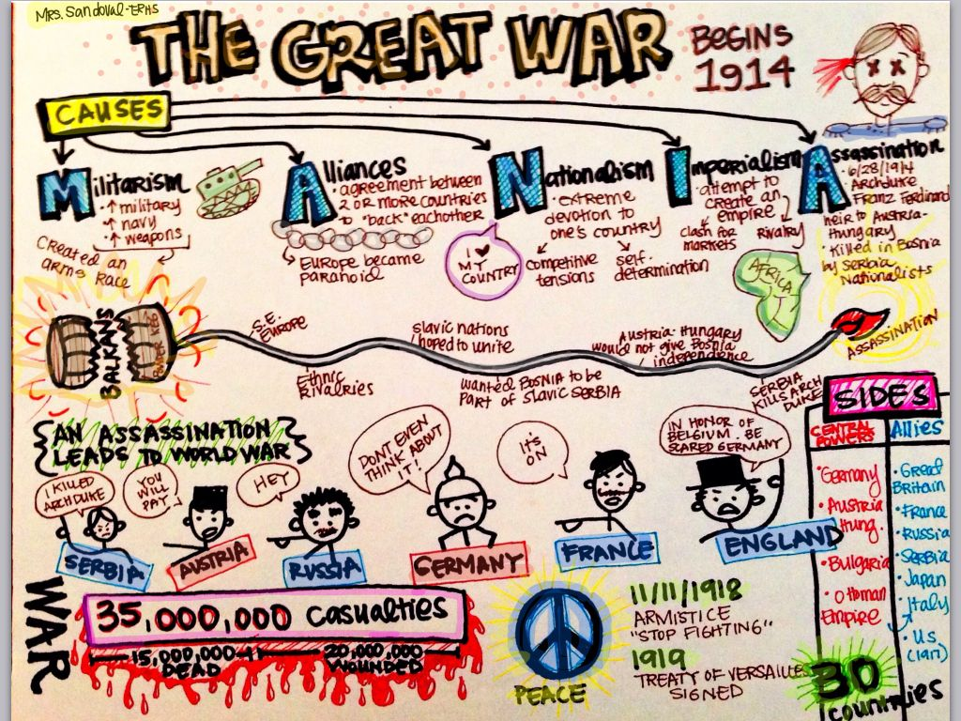

**Period 4:**

**Analysis:**

In this level, children learn to identify the separate qualities of a topic and compare, contrast, and classify them.

Students will make copy of maps of the world in 1914 in black and white (able to be colored in) Colored crayons/markers/colored pencils Materials Map of the world in 1914 Coloring pens (8 different colors)

They will make a list of the countries that controlled what territory in the world

Method:

* Students will work as a class to decide which colors will represent which countries
* Students will use these colors to color in the territories that are under control of which nations.
* As a class, we will go over each continent and talk about which countries controlled what.
* Students will be reintroduced to the idea of imperialism—why did the race to control territory happen?

Once they are done with this, they will do the following:

*Activities:*Children may do one or all of the following:

* 1. Examine the reasons for the formation of the alliances.
  2. Create a questionnaire
  3. Write an essay explaining how the world has changed from 1914 to present day. Has the world map changed? How?

**Period 5:**

**Create**

Children at this level will combine ideas from the lesson and from other sources. They will be able to do the following:

*Activities:*Children may do some or all of the following:

* Make copies the 8 nation’s flags—1 for each student
* Materials required: Copies of national flags for the 8 nations List of dates and important details about the alliances in a handout

**Method:**

* Begin discussion about what an alliance is— with their personal experiences (sports, games, in a story, etc.)
* Discussion about why a nation might make an alliance with another nation- can you think of any nation in the recent past which has taken help or formed an alliance?
* Ask the students come up to the front and grab a flag—make sure that all countries are represented
* Have the students group themselves based on flags
* Walk through the different flags—try to find out which flags represent what nation

Explain the activity: When their country alliances are called, the two nations are to move together and link arms

* If a nation has multiple alliances, they need to be linked to each country they have an alliance with.
* By the end of the activity, students will be able to see which countries had alliances with which other countries

**Home Assignment:**

Scenario: Imagine what it would be like to participate in the discussions about the WWI if the students were present at that time.

1. Imagine what Archduke Ferdinand would be like if he lived today
2. Imagine being part of the proceedings leading up to the War and write a diary about their experiences
3. Write a newspaper article about the causes of WWI
4. Write a story about Archduke Ferdinand waking up one day to find himself in the modern world

Example: Newspaper designing:

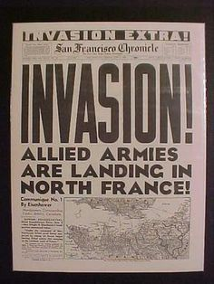

**Period 6:**

**Evaluation**

In this level, children evaluate events and people using specific criteria. They will be able to do the following:

*Activities:*

Children may do some or all of the following:

1. Explain why they agree or disagree with the decisions made concerning the alliances. Compare and contrast the situations if the alliances had not taken place.
2. As you read more, you want to explain how the technological advances make this war deadlier and more devastating? Support your answer with examples.
3. What changes would you have made to the strategies used during the war? Justify your answer.
4. Convince your readers what we can learn from how this War started in order to help prevent future devastating conflicts.

The lesson will end after a presentation of the story/summary that the children will work on depicting the assassination and the causes of WWI.